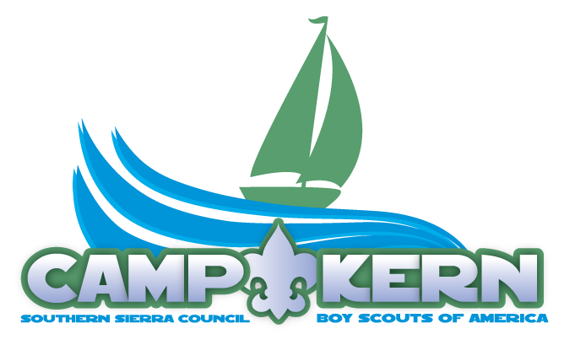

Harbor Staff

Since 1939, Camp Kern has helped scouting leaders mold the youth they serve by combining educational activities and lifelong values with fun in the High Sierra. The Boy Scouts of America believes and understands that helping youth puts us on a path towards a more conscientious, responsible and productive society.
Staffers at Camp Kern are a diverse group of men and women working in a dynamic and fulfilling workplace. This is work that makes a difference and calls one to continual learning and challenge.

The Harbor Staff selected will:

- Execute the ingress and egress of all persons and property in and out of camp via harbor operations.
- Install outboard motors on all vessels in accordance with manufactures instructions and with all safety equipment properly installed and functioning.
- Maintain vessel engines, vessels, docks, caissons, storage facilities, anchors, buoys and harbor areas in accordance with maintenance schedule including oil and filter changes, wiring and lighting, hose repair or replacement, mooring line replacement, painting and tread surface work as common examples.
- Operate barges with proper loading, unloading and securing of all loads.
- Operate barges with proper loading, unloading safety, and welcome briefings and “tour guide” information conveyed on the float itself.
- Execute the preventative maintenance plan for harbor operations in conjunction with the Harbor Master.
- Receive orders verifying all documents align with what is received. Sign for shipping orders and deliver originals to the receiving department within 3 hours of receipt.
- Maintain adequate fuel reserves.
- Collect mail Monday - Saturday when assigned.
- Follow approved barge schedule arriving on time, without injury or property damage.
- Utilizes business tools provided by camp management in the execution of a preventative maintenance plan.
- Serve as a back up to the Harbormaster if he or she is unavailable to address an urgent matter related to the vessels, engines or docks.
- Inspect fleet vessels for readiness and service.
- Properly log each voyage in the log.
- Execute the portions of the Solid Waste Management Plan as they relate to harbor operations.
- Execute a critical role in emergency procedures to protect life and property.
- Serve as an adjunct member of the ranger staff including operation of equipment, building repair, plumbing repair, mechanical work, painting, and other related tasks and skills.
- Communicate with the Harbor Master and/or camp management regarding any deviations to the barge schedule.
- Other duties as assigned.

Desired Skills:

- Must be comfortable with public speaking and interacting with diverse audiences.
- Excellent people skills, enthusiastic, punctual, responsible and creative.
- Detail-oriented.
- Customer service focused.
- Self-motivated individual with solid time management.
- Committed to personal and professional productivity, while maintaining high ethical and professional working standards.

Requirements:

- Must be willing to accept and meet the Boy Scouts of America’s leadership and membership standards and subscribe to the Scout Oath and Law.
- Meet the job requirements as listed in the staff application before the first day of employment.
- Ability to work varied hours when necessary. Evening and weekend work is frequently required to achieve positive objectives.

I have reviewed the job description and understand all expectations and requirements.

Name: _________________________________________________________

Signature: _________________________________________________

Date: _______________

(Please return with the rest of your paperwork, maintain a copy for your records)

